**Lab 5 Assignment**

**Prudhvi Nalluri (16163411)**

**Murali K Kalvakuri (16156599)**

In this Assignment we took 2048 open source project and added a motion recognition feature to it by using the motion recognition apps provided in the blackboard, so that it will take input motion from the sensor and will give response according to that input: left, right, up, down.

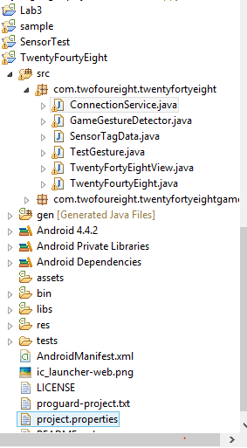

The ConnectionService, SensorTagData and TestGesture classes are imported into our project and defined the connection service in the manifest file and given the Bluetooth permissions to it and imported the jahmm jar file into the libs folder.

**The Main Work Flow:**

TwentyFourtyEight class -> GameGestureDetector class -> TwentyFourtyEightGame class -> onLeft () function;

When a gesture a made the ConnectionService takes the input gesture and send it to the TestGesture class (test function) to determine what gesture is made by the sensor by checking with the train sequences files we created in lab4 and returns the pattern made and in ConnectionService class we call the onFling function which is in GameGestureDetector class.

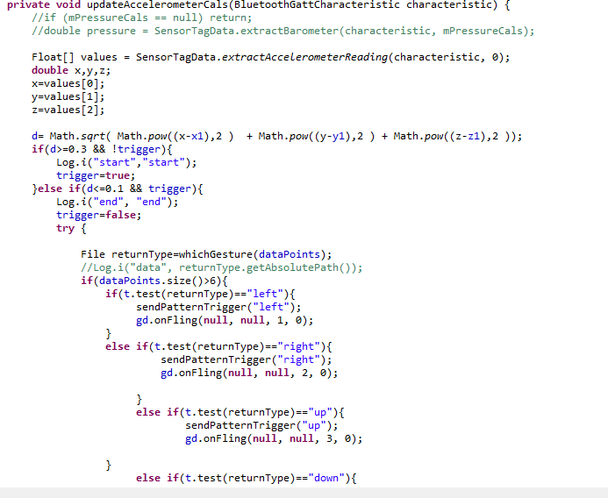

This is the code for ConnectionService class where it is calling onFling function in GameGestureDetector class after the Motion is recognized.

In the GameGestureDetector class the function takes input (pattern) from the ConnectionService class and call the function (left,right, e.t.c) which is in the TwentyFourtyEightGame class

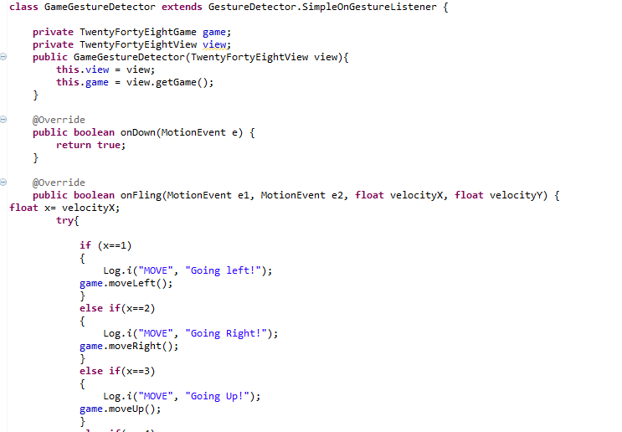

This is the GameGestureDetector class code we edited in order to response to the gesture made by the sensor.

In the TwentyFortyEightGame class the actual onRight (), onLeft () functions are declared where actual movement of tiles are made.

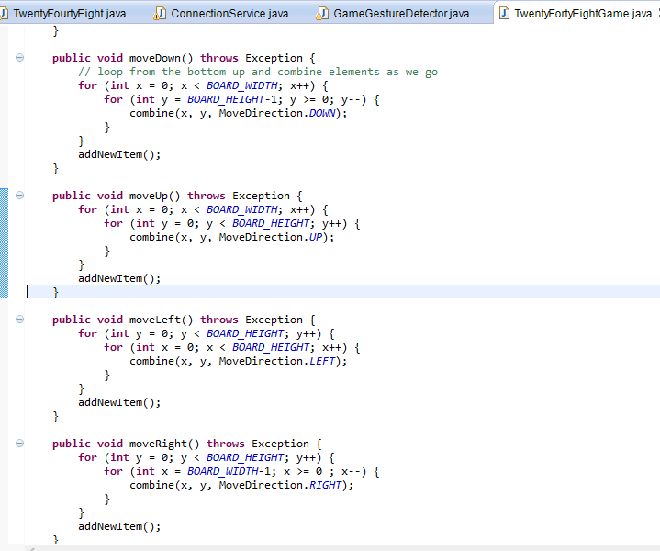

These are the functions we called in the GameGestureDetector class when a gesture is made by the sensor.

